RFID-RC522 Sensor
It senses your card/keychain and then turns on either a green or red led.
Este documento foi desenvolvido por Andrei Inoue Hirata está protegido por direitos autorais, sendo vedada sua reprodução sem autorização prévia do autor.

Components and supplies
- 1 Arduino Uno Rev3
- 1 5 mm LED: Green
- 1 5 mm LED: Red
- 1 RFID Module (Generic)
- 11 Jumper wires (generic)
- 1 RFID Module (Generic)
- 1 Breadboard (generic)

Project description
I am trying to make a lock for my door like the ones at hotels, and also the leds the green one goes to pin 7 and red goes to pin 6 on the big power side (longer side) and the other side (smaller side) goes to GND

Code

#include <SPI.h>
#include <MFRC522.h>

#define SS_PIN 10
#define RST_PIN 9
#define RED 2
#define Green 3
MFRC522 mfrc522(SS_PIN, RST_PIN); // Create MFRC522 instance.

void setup()
{
Serial.begin(9600); // Initiate a serial communication
SPI.begin(); // Initiate SPI bus
mfrc522.PCD_Init(); // Initiate MFRC522
Serial.println("Approximate your card to the reader...");
Serial.println();
pinMode(LED_BUILTIN, OUTPUT);
digitalWrite(LED_BUILTIN, LOW); // turn the LED off by making the voltage LOW
digitalWrite(Green, LOW);
digitalWrite(RED, LOW);

}
void loop()
{
// Look for new cards
if ( ! mfrc522.PICC_IsNewCardPresent())
{
return;
}
// Select one of the cards
if ( ! mfrc522.PICC_ReadCardSerial())
{
return;
}
//Show UID on serial monitor
Serial.print("UID tag :");
String content= "";
byte letter;
for (byte i = 0; i < mfrc522.uid.size; i++)
{
Serial.print(mfrc522.uid.uidByte[i] < 0x10 ? " 0" : " ");
Serial.print(mfrc522.uid.uidByte[i], HEX);
content.concat(String(mfrc522.uid.uidByte[i] < 0x10 ? " 0" : " "));
content.concat(String(mfrc522.uid.uidByte[i], HEX));
}
Serial.println();
Serial.print("Message : ");
content.toUpperCase();
if ((content.substring(1) == "1A 7C 78 30") || (content.substring(1) == "CC CC A3 16") ) //change here the UID of the card/cards that you want to give access
{
Serial.println("Authorized access");
Serial.println();
digitalWrite(LED_BUILTIN, HIGH); // turn the LED on (HIGH is the voltage level)
digitalWrite(Green, HIGH);
delay(10000);
digitalWrite(Green, LOW);
}

else {

Serial.println(" Access denied");
digitalWrite(LED_BUILTIN, LOW); // turn the LED off by making the voltage LOW
digitalWrite(RED, HIGH);
delay(10000);
digitalWrite(RED, LOW);

}
}
#include <SPI.h>
#include <MFRC522.h>

#define SS_PIN 10
#define
RST_PIN 9
#define RED 2
#define Green 3
MFRC522 mfrc522(SS_PIN, RST_PIN);
// Create MFRC522 instance.

void setup()
{
Serial.begin(9600);
// Initiate a serial communication
SPI.begin(); // Initiate SPI bus

mfrc522.PCD_Init(); // Initiate MFRC522
Serial.println("Approximate your
card to the reader...");
Serial.println();
pinMode(LED_BUILTIN, OUTPUT);

digitalWrite(LED_BUILTIN, LOW); // turn the LED off by making the voltage
LOW
digitalWrite(Green, LOW);
digitalWrite(RED, LOW);

}
void
loop()
{
// Look for new cards
if ( ! mfrc522.PICC_IsNewCardPresent())

{
return;
}
// Select one of the cards
if ( ! mfrc522.PICC_ReadCardSerial())

{
return;
}
//Show UID on serial monitor
Serial.print("UID
tag :");
String content= "";
byte letter;
for (byte i = 0; i <
mfrc522.uid.size; i++)
{
Serial.print(mfrc522.uid.uidByte[i] < 0x10
? " 0" : " ");
Serial.print(mfrc522.uid.uidByte[i], HEX);
content.concat(String(mfrc522.uid.uidByte[i]
< 0x10 ? " 0" : " "));
content.concat(String(mfrc522.uid.uidByte[i],
HEX));
}
Serial.println();
Serial.print("Message : ");
content.toUpperCase();

if ((content.substring(1) == "1A 7C 78 30") || (content.substring(1) == "CC
CC A3 16") ) //change here the UID of the card/cards that you want to give access

{
Serial.println("Authorized access");
Serial.println();
digitalWrite(LED_BUILTIN,
HIGH); // turn the LED on (HIGH is the voltage level)
digitalWrite(Green,
HIGH);
delay(10000);
digitalWrite(Green, LOW);
}

else
{

Serial.println(" Access denied");
digitalWrite(LED_BUILTIN,
LOW); // turn the LED off by making the voltage LOW
digitalWrite(RED,
HIGH);
delay(10000);
digitalWrite(RED, LOW);

}
}

Schematics
Xxxxxxxx
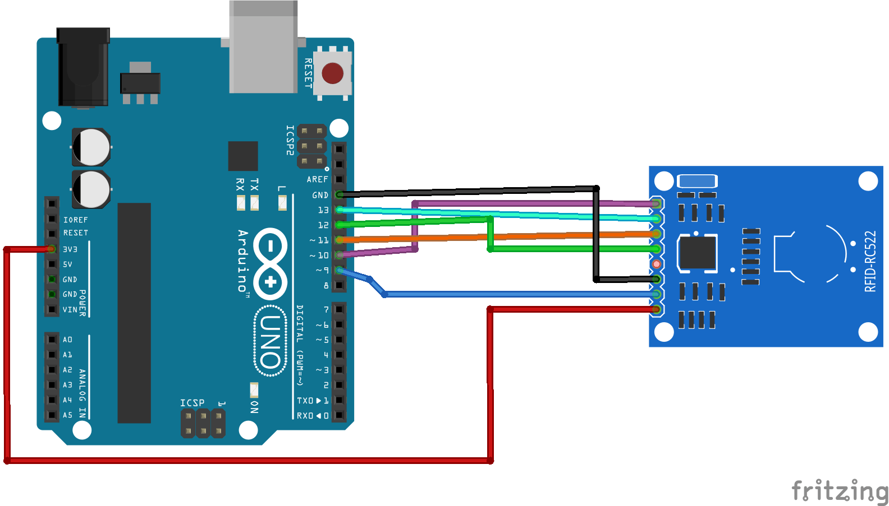

Referencias
https://projecthub.arduino.cc/person87/rfid-rc522-sensor-64000f

